PENETRATION TESTING REPORT
FOOTPRINTING & NETWORK SCANNING PHASES
W2-PM-FINAL | Cybersecurity Internship | NETWORKWALKS

Pen tester Name (Cybersecurity Professional) | Abbas Ali Gedi
Program/Batch | B082 – Networkwalks
Date | 20 August 2026
Modules Completed | W2-PM4 (theHarvester) and W2-PM5 (Zenmap Scanning)
Client/Target | 1. networkwalks.com (training/lab target)  2. My own local Wi-Fi/LAN
Permission / Scope | Authorized training activity and scanning of my own local network
Phases Covered | Phase 1: Reconnaissance & Footprinting  Phase 2: Scanning & Network Discovery

1. Liability Disclaimer
I performed these activities only against the authorized training target and devices/network resources that I own. The work is for educational and cybersecurity research purposes only. No exploitation, credential attacks, persistence, or destructive actions were performed. Unauthorized access or scanning may be illegal; therefore, the techniques in this report must only be used within an explicitly authorized scope.

2. Introduction
This report documents two Week 2 practical activities. First, theHarvester was used from Kali Linux to perform passive footprinting of the networkwalks.com training domain. Second, Nmap/Zenmap was used from a Windows machine to discover hosts on my own local Wi-Fi network and generate a topology view. The evidence shows the commands, observed results, limitations, and security relevance of the findings.

3. Tools Used
Tool | Purpose
Kali Linux | Operating system used for theHarvester reconnaissance activity.
theHarvester 4.10.1 | Collect public-domain information such as emails, IPs, hosts, subdomains and related infrastructure.
Zenmap / Nmap 7.991 | Discover live hosts, identify open ports and visualize network topology on the local LAN.
Windows CMD / ipconfig | Identify local network interface configuration and the subnet used for scanning.

4.1 OSINT Footprinting & Reconnaissance
I performed passive reconnaissance using theHarvester 4.10.1 in Kali Linux against the authorized target networkwalks.com.
Step 1: Baidu Search
I first used Baidu as the search source:
theHarvester -d networkwalks.com -l 1000 -b baidu
The scan returned 0 IPs, 0 emails, 0 people, and 0 hosts.
Step 2: Multiple Sources
I then performed a broader search using all available sources:
theHarvester -d networkwalks.com -l 50 -b all
The scan identified 3 ASNs, 2 URLs, 1 email address, IP information, and 32 hosts/subdomains.
Step 3: Review Results
I reviewed and documented the collected information. Some sources required API keys, so not every available source returned results.
Step 4: Evidence
Screenshots of theHarvester commands and results were collected and included as evidence in this report.
This activity demonstrated how OSINT techniques can be used to identify publicly available information about a target without attempting unauthorized access.
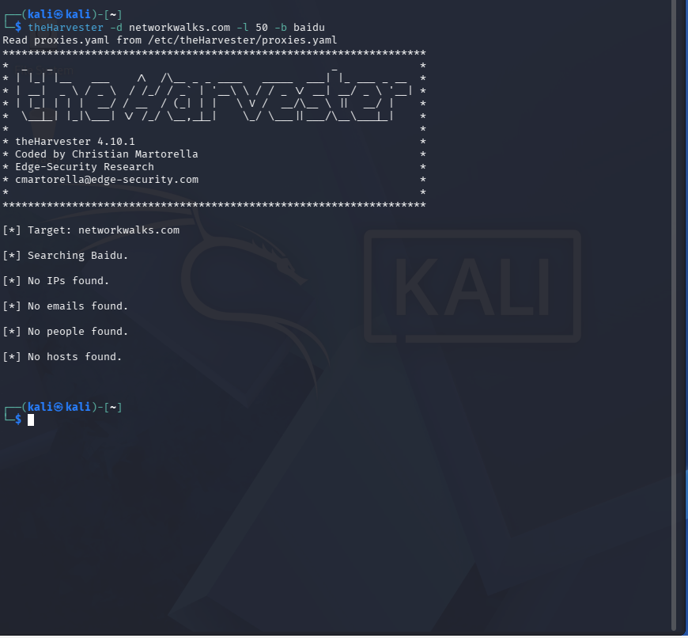
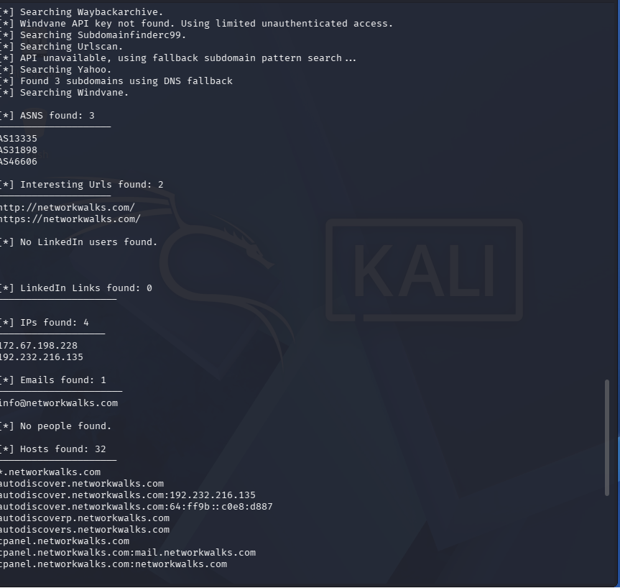

4.2 Network Scanning with Zenmap
For the second practical activity, I scanned my own local Wi-Fi/LAN. The Windows ipconfig command was used first to identify the local interface and network range. Sensitive local IP and MAC values have been masked in the evidence images included in this report.
Observed local network: 10.xx.xx.0/24 (sensitive address values masked in evidence).
Step 1: Identify local network configuration
Command: ipconfig /all
The command displayed the Windows Wi-Fi adapter, IPv4 configuration, subnet mask, default gateway, DHCP/DNS information and hardware address. These values were used only to determine the local scanning scope.
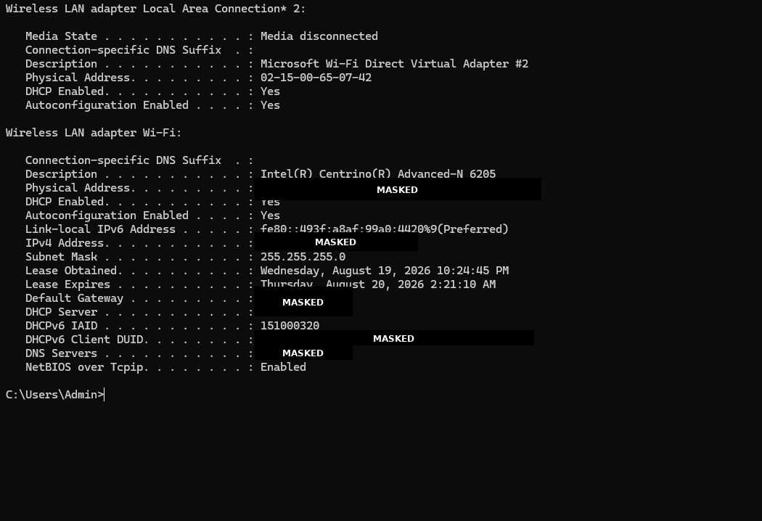
Command: ipconfig
The shorter ipconfig output confirmed the local Wi-Fi IPv4 configuration and the /24 subnet used for the discovery scan.
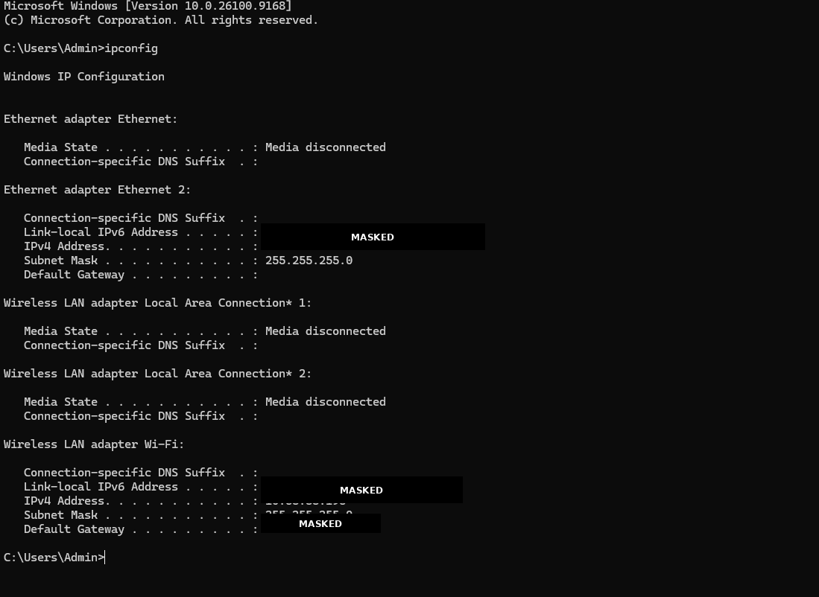

Step 2: Zenmap / Nmap host discovery and service scan
Scan result: 3 hosts were up on the scanned 256-address range.
The Nmap result identified three live hosts. One host exposed DNS on TCP/53, while the Windows host exposed TCP/135, TCP/139, TCP/445 and TCP/7070. The report evidence masks the local IP addresses and preserves the topology structure.
Host role (masked) | Observed ports | Observation
Host A (masked) | No open ports shown; 100 scanned ports were closed/ignored | Host was reachable but did not expose an open TCP service in the reported scan.
Host B (masked) | 53/tcp – domain | DNS service was reachable on TCP/53.
Host C (masked) | 135/tcp – msrpc; 139/tcp – netbios-ssn; 445/tcp – microsoft-ds; 7070/tcp – realserver | Windows-related services and an additional service were reachable and should be reviewed on an owned system.
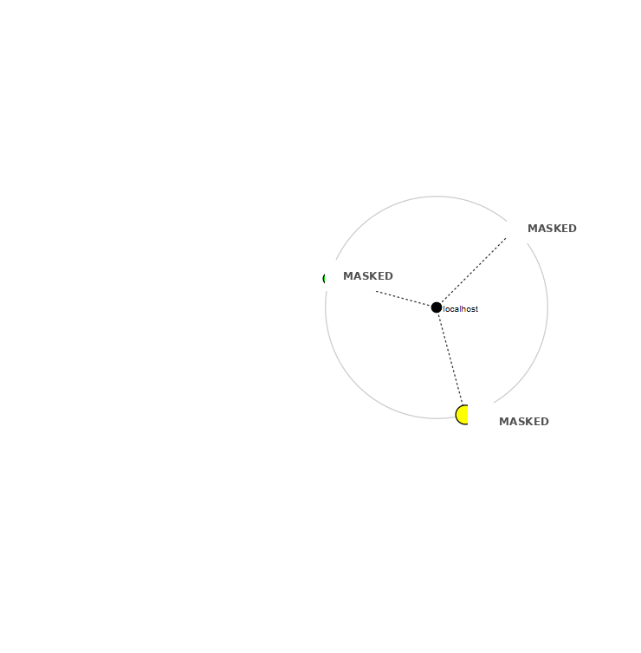

5. Risk Analysis / Impact
The following are observations from the footprinting and internal host-discovery exercises. They are not confirmed vulnerabilities. No exploitation or vulnerability validation was performed.
Risk | Level | Evidence | Potential impact
Public email exposure | Medium | info@networkwalks.com was returned. | May support phishing or social engineering if not protected by other controls.
Large public host/subdomain footprint | Medium | 32 host/subdomain entries were reported. | More externally visible endpoints may increase the attack surface.
DNS service on local host | Low–Medium | TCP/53 was open on one discovered local host. | An exposed service should be intentional, patched and restricted to required clients.
SMB/NetBIOS services on local Windows host | Medium | TCP/139 and TCP/445 were open. | These services should be limited to trusted networks and kept patched to reduce lateral-movement risk.

6. Recommendations
1. Reduce public information exposure — Review public contact information and use controlled contact mechanisms where appropriate to reduce phishing exposure.
2. Review public subdomains — Confirm that cPanel, FTP, mail, webmail and related endpoints are required. Restrict administrative services and enforce strong authentication.
3. Harden local Windows services — Review TCP/135, TCP/139 and TCP/445 on the Windows host. Disable unused services and maintain current security patches.
4. Restrict DNS exposure — Confirm that TCP/53 is required on the discovered host and restrict DNS service access to authorized clients.
5. Maintain an internal asset inventory — Regularly scan the owned LAN to identify unknown or unauthorized devices.
6. Protect network documentation — Keep IP addresses, MAC addresses and topology diagrams private. The screenshots in this report intentionally mask those local identifiers.
7. Scan only within authorization — Continue performing reconnaissance and scanning only against authorized targets or systems owned by the tester.

7. Conclusion
During Week 2 of the Cybersecurity & Ethical Hacking program, I completed practical activities covering footprinting, reconnaissance and network scanning. Using theHarvester, I collected public information associated with networkwalks.com, including an email address, IP information, ASNs, URLs and a set of host/subdomain records. The exercise also demonstrated that reconnaissance results depend on the availability and authentication requirements of individual data sources.
Using Zenmap/Nmap on my own local Wi-Fi network, I identified three live hosts and observed several reachable services. I also generated a topology showing the relationships between the discovered nodes. The exercise reinforced that network discovery should be performed carefully and within a defined scope.
Finally, I learned that a professional security report should document the command used, the evidence obtained, the meaning of the observation, the potential security impact and practical recommendations. Local IP and MAC identifiers were masked in this report to protect the privacy of the local network.

— End —
Author
Abbas Ali Gedi
Cybersecurity & Ethical hacking internship at Network walks – B082
Program Name: Cybersecurity program at Networkwalks | Week: 02 | Repository: GitHub

